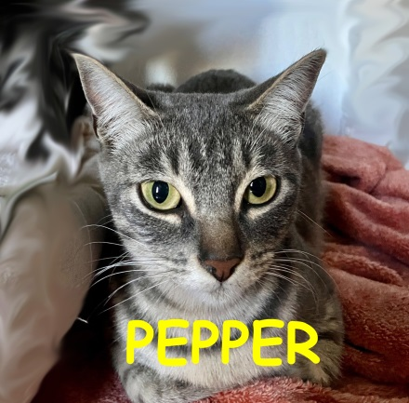
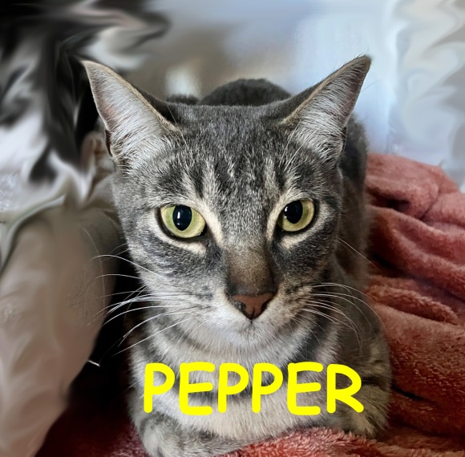
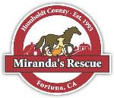
Come and meet Shannon Miranda
and all the adoptable
kitties and doggies!

MIRANDA’S RESCUE

ADOPTION FAIR

A generous donor will be paying

half of all adoption fees!

Come and meet your new best friend
Saturday and Sunday March 23rd and 24th
Saturday 10am – 4pm and Sunday noon – 4pm
1603 Sandy Prairie Road, Fortuna, CA 95540
707-725-4449 – www.mirandasrescue.org

